Institute of Grace News: Feb 2016

The January trip was a great success with team from Glen Mar UMC. We stayed for ten days and had a relaxed and productive visit. The team hosted a pastor’s seminar with 39 pastors, finished priming and painting all but four rooms of the 2nd floor in the main building, and worked for several days with EGF school. We used the showers in the guest house for the first time and fixed a generator that had not worked for months.

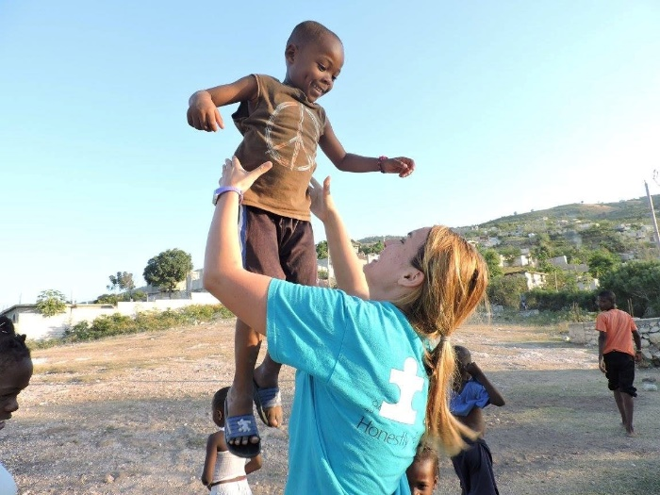 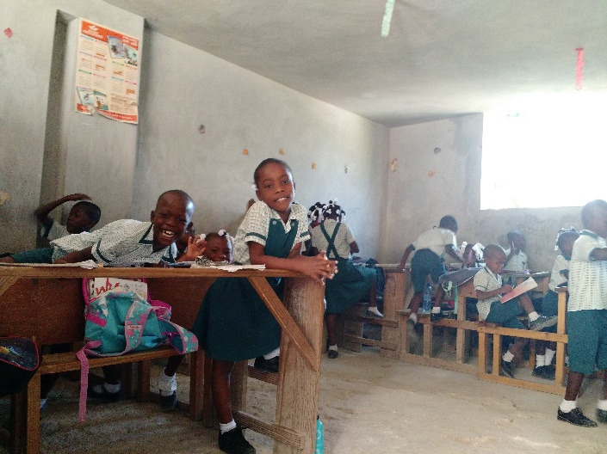

Interaction with the children and staff was a blessing and we worshipped at Pastor Marckenson’s church. We also explored projects for the teams coming in March and June.

If you are interested in coming to Haiti with an already scheduled team, we have four spots open on a team with Silver Spring UMC, MD from March 28 to April 3. And there are multiple spots available June 16-24 with St Paul UMC in Lusby, MD. The cost for each trip is planned at $700 plus airfare. Please contact me for more details if you are interested. I will be going with both teams and very excited about what we have planned.

If you would like to support a child or teacher or the medical clinic with regular donations, we have a new PO Box for donations. Or if you prefer, we can also accept electronic transfers. Please contact me for more details about this option. As has been our practice for years, all our support goes to Haiti as all our salaried employees are in Haiti.

Thanks for your support as we work with the people of Haiti.

*David Graves*

Address for contributions: Institute of Grace

PO Box 2364

Leesburg, VA 20177